MSCF Programming Prep
Homework 1

Due At 10:30am Monday, Aug. 7, Before Lecture

- (70 points) Commodity futures and option contracts of many kinds are traded on NYMEX, owned by CME Group. Each evening of each trading day, sometime between about 6:00 pm and 8:00 pm Central Time, a SPAN (Standard Portfolio Analysis of Risk) file is posted to ftp://ftp.cmegroup.com/pub/span/data/cme containing information about the day’s trading. For a given day, the name of this file is cme.YYYYMMDD.c.pa2.zip, where YYYYMMDDD is the 8-digit year, month, and day of the file. Files for months prior to the current month are moved into the /pub/span/data/cme/2017 subdirectory.

Download the zipped SPAN file for Monday, July 31, 2017, cme.20170731.c.pa2.zip. Unzip, then display this SPAN file. You will see that it is an enormous text file with its own unique format, unfortunately not something simple and convenient like CSV or XML or JSON.

The settlement prices contained in the SPAN file are used to mark to market each trader’s account, so that gains/losses can be credited/debited each day to reduce the risk of counterparty default. Your job is to extract these settlement prices, as well as contract expiration dates (last trading dates), for two of the most heavily traded energy contracts: West Texas Intermediate (WTI) Crude Oil, and Henry Hub Natural Gas.

To learn about WTI Crude Oil futures contract details, check out: http://www.cmegroup.com/trading/energy/crude-oil/light-sweet-crude_contract_specifications.html

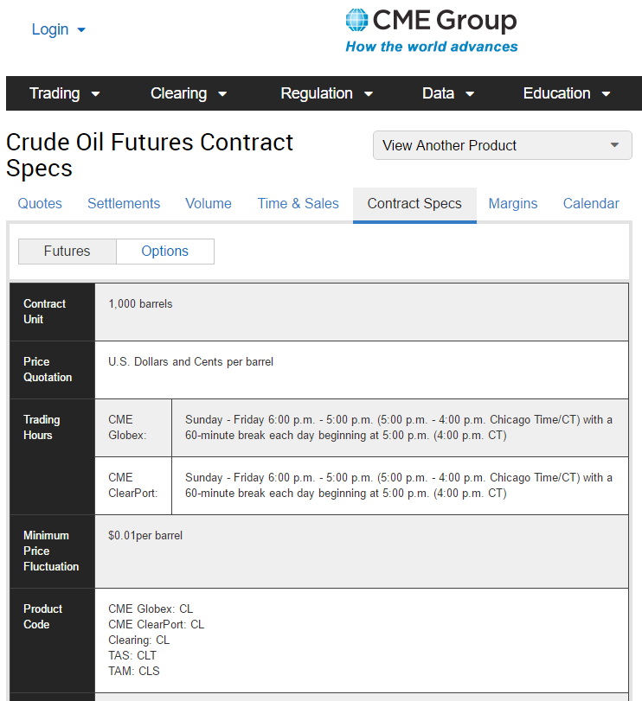

Notice that the CME Globex Product Code is CL; you will need this for scanning the SPAN file. Using other tabs at the top of this page, you can see current quotes, recent settlements, volume, etc. If you click the Options button, just to the right of the Futures button near the upper left, you will see information about options contracts based on the underlying futures contracts. There are about two dozen different types of option contracts for this underlying; we are interested in the American Options. When you look at the contract specifications, you will discover that its Product Code is LO.

In the View Anther Product menu at upper right, select Natural Gas (Henry Hub) Physical Futures to learn analogous information about natural gas futures contracts and the corresponding American option contracts.

Write a C++ program named hw1.1.cpp that reads cme.20170731.c.pa2 as its input file, and produces CL_and_NG_expirations_and_settlements.txt as its output file. The output should be in exactly this form:

Futures Contract Contract Futures Options Options
Code Month Type Exp Date Code Exp Date
------- -------- -------- -------- ------- --------
CL 2017-10 Fut 2017-09-20
CL 2017-11 Fut 2017-10-20
… and so forth, through contract month 2019-12 …
CL 2017-10 Opt LO 2017-09-15
CL 2017-11 Opt LO 2017-10-17
… and so forth, through contract month 2019-12 …
NG 2017-10 Fut 2017-09-27
NG 2017-11 Fut 2017-10-27
… and so forth, through contract month 2019-12 …
NG 2017-10 Opt ON 2017-09-26
NG 2017-11 Opt ON 2017-10-26
… and so forth, through contract month 2019-12 …

Futures Contract Contract Strike Settlement
Code Month Type Price Price
------- -------- -------- ------ ----------
CL 2017-10 Fut 50.26
CL 2017-11 Fut 50.37
… and so forth, through contract month 2019-12 …
CL 2017-10 Call 5.50 44.79
CL 2017-10 Put 5.50 0.01
CL 2017-10 Call 6.00 44.29
CL 2017-10 Put 6.00 0.01
… and so forth, through contract month 2019-12 …
NG 2017-10 Fut 2.834
NG 2017-11 Fut 2.920
… and so forth, through contract month 2019-12 …
NG 2017-10 Call 0.250 2.598
NG 2017-10 Put 0.250 0.001
NG 2017-10 Call 0.500 2.348
NG 2017-10 Put 0.500 0.001
… and so forth, through contract month 2019-12 …

Do not try to create a better output format: it needs to be very easy for us to compare your output to our solution output, and to other students’ outputs. We will take off points if your output format varies too much from what is shown above. Our output format takes into account the order in which records appear in the SPAN file, so you don’t have to remember or accumulate too much information as you go.

Do not include contract months earlier than 2017-10, or later than 2019-12.

Since there are many, many strike prices for options on futures contracts, the output file is going to be very long, but not nearly as long as the SPAN file itself.
Fortunately, there is documentation online that describes the contents of CME SPAN files. If you Google for “cme span pa2 file format” you will find a page named “Risk Parameter File Layouts for the Positional Formats – SPAN…”. You will want to look at Type “B” Records, Expanded Format, and Type “8” Records, Expanded Format, to learn how to obtain the contract name, type, month, expiration date, strike, and settlement prices that you need.

A few hints:

(a) Notice that the documentation counts character column positions from 1, whereas in your code you will need to count character positions from 0 for substr or other purposes

(b) Check the contract specifications to discover the number of decimal places you should display for prices of different commodity futures and options contracts.

(c) You will discover that the documentation is not quite perfect, but you should be able to figure out any problem(s) you encounter. (Sub-hint: talk to others.)

(d) Approach the program in stages: first, make sure you can write a program that simply copies the SPAN file to the output file; next, copy the type B and type 8 records from the SPAN file to the output file; next, copy the type B and type 8 CL records; next, the type B and type 8 CL and NG records; and so forth, making definite steady progress with each revision. As your coding skills improve, you can do two or three or four things in each revision step. Eventually, you will find that you can write dozens of lines of code encompassing many different tasks and goals, and it will compile and work the first time! But maybe not every time.

(e) You can use any C++ facilities that you know, but you should not need anything other than what was discussed in the Day 1 through Day 4 Lecture Notes and the “Various Things” document.

(f) Remember the Discussion board, roehrig@cmu.edu, and jostlund@andrew.cmu.edu.

At the top of your source code file, put in comments including this information:

// Programming Prep, Fall 2017
// Homework 1.1
// File: hw1.1.cpp
// Authors: the names of the two or three homework partners
// Description: [what does your program do? Be clear, complete and concise.]

Comment your code as you deem necessary: major steps, or tricky logic. Don’t include gratuitous comments, like:

int main() // this is the main function, that takes no parameters and returns int

Choose meaningful, so-called self-documenting variable names. For example:

double strike_price; /* this is good! No comment necessary */

double sp; // strike price /* this is lazy and stupid, even with comment */

- (15 points) We have used the C++ fundamental data types int and double. Each of these is able to store values in an implementation-defined range. On 64-bit systems, such as our laptops, the typical range of values for int is roughly +/-2 billion. What happens when you go outside this range?

  - Write a program named hw1.2.cpp that has one int variable, and assign the value 1000000000 (1 billion) to this variable. Display the value using cout.
  - Now, triple the variable’s value and display the new result. Does your program crash? What is going on? Explain.
  - Triple the value again and display. Explain.
  - In your program, add a double variable with the initial value 1.0. Display the value using cout. How many times can you increase this variable’s value by a factor of 2 before you get a “crazy” result?
  - Have a look at cplusplus.com to find out about the climits standard header and the INT_MAX constant. Add another int variable to your program with initial value INT_MAX, then display the variable’s value. What is INT_MAX on your laptop?
  - Add 1 to the variable. What is its value now? Explain.

Add the necessary course name/Homework 1.2/File/Authors/Description comment block at the top of your source code file. Add comments in your source code giving your results and explanations for questions (a) through (f).

- (15 points) Constants like INT_MAX in <climits> and DBL_MAX in <cfloat> give minimum and maximum values of your compiler’s integer and floating point fundamental data types. The sizeof operator applied to a data type tells how many bytes of memory a variable of that type occupies. For example, on your laptop sizeof (int) is most likely 4, and sizeof (double) is most likely 8. Notice that the type name is enclosed in parentheses: sizeof (type_name). You can also use sizeof to find out the size of a variable or a constant; in this case, the parentheses are not required:

int i = 12;
cout << "sizeof (int): " << sizeof (int) << "\n";
cout << "sizeof i: " << sizeof i << "\n";
cout << "sizeof 12: " << sizeof 12 << "\n";
cout << "sizeof 12.3: " << sizeof 12.3
<< "\n"; // 12.3 has type double

Even though we are not going to be using all of the C++ fundamental data types in this course, you should nevertheless have some knowledge of their sizes and ranges on any machine you are programming on.

Write a program named hw1.3.cpp that displays the sizes and ranges of values on your system of all the fundamental data types (except void and nullptr):

bool char signed char unsigned char
short int long long long
unsigned short unsigned unsigned long unsigned long long
float double long double

(Although signed char and unsigned char are the same size as a char, these types are really intended as very small signed and unsigned integer data types, respectively. At one point during the standardization process, the committee gave consideration to calling these short short int and unsigned short short int, in symmetry with long long int and unsigned long long int.)

Comment your code as you deem necessary, and add the needed comment block at the top of your source code file.

And Finally

Submit your homework electronically to Canvas. You and your partner should submit a single .zip file, containing the three source code files you wrote for the three parts of this homework.

